Advance AI project(Genetic algorithm)
Prepared by the student: Albara khalid almaseidiyen.

implementation
1.Definition of required functions:
Function Name | What It Does
load_network | Reads the network data file and returns a DataFrame.
initialize_population | Creates a random initial population of chromosomes.
fitness | Evaluates the quality of a chromosome (how good a solution it is).
tournament_selection | Selects a parent using a fitness-based tournament.
two_point_crossover | Produces offspring by combining genes from two parents.
mutate | Introduces random changes in a chromosome to maintain diversity.
genetic_algorithm | Runs the full GA process, including selection, crossover, and mutation.

2. Loads the network data and extracts the cost matrix:
network_data = load_network("network.txt")
cost_matrix = network_data["Cost"].values
total_cost = np.sum(cost_matrix)

3.Definition of required parameters:
Initial Parameters:
ga_params = {
"POPULATION_SIZE": 100,
"CROSSOVER_RATE": 0.7,
"MUTATION_RATE": 0.001,
"MAX_GENERATIONS": 1000,
"TOURNAMENT_SIZE": 3
}
4.Running the Genetic Algorithm:
best, avg = genetic_algorithm(cost_matrix, total_cost, ga_params)
5.visualizing the results:
plt.plot(best, label="Best Fitness")
plt.plot(avg, label="Average Fitness")
plt.xlabel("Generations")
plt.ylabel("Fitness")
plt.title("Genetic Algorithm Performance")
plt.legend()
plt.show()

experiments
To get a better understanding of how the parameters affect the algorithm's performance, we will run multiple times with one parameter changing in each run.
1. Initial Run:
Parameters:
POPULATION_SIZE: 100
CROSSOVER_RATE: 0.7
MUTATION_RATE: 0.001
MAX_GENERATIONS: 1000
Result:
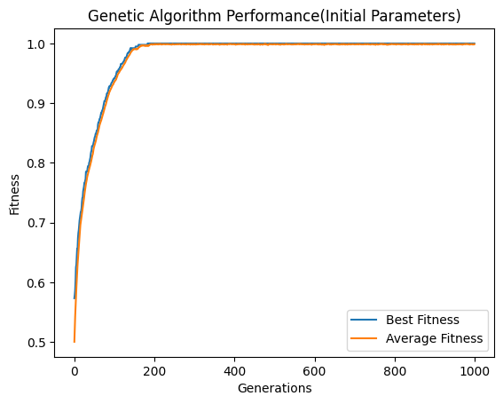

2.Low and High Crossover Rate Runs:
Parameters:
Low CROSSOVER_RATE: 0.4
High CROSSOVER_RATE: 1
Results:
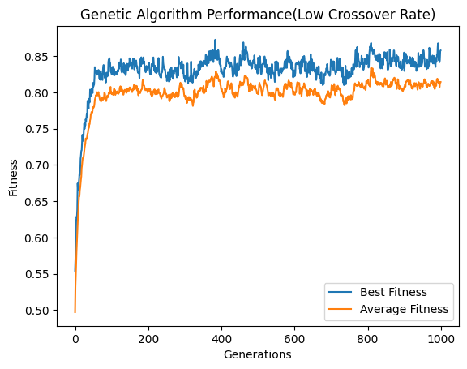
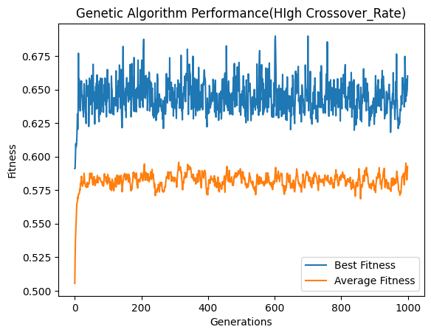

Low and High Mutation Rate Runs:
Parameters:

3.Low and High Mutation Rate Runs:
Parameters:
Low MUTATION_RATE: 0.000001
High MUTATION_RATE: 0.1
Results:
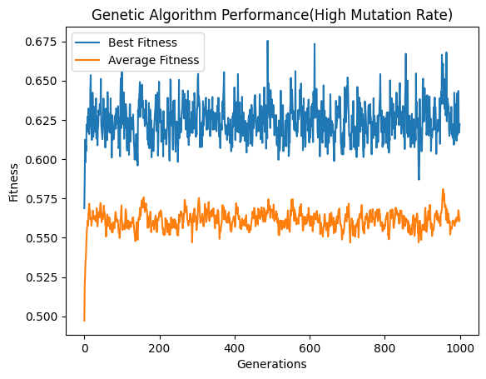
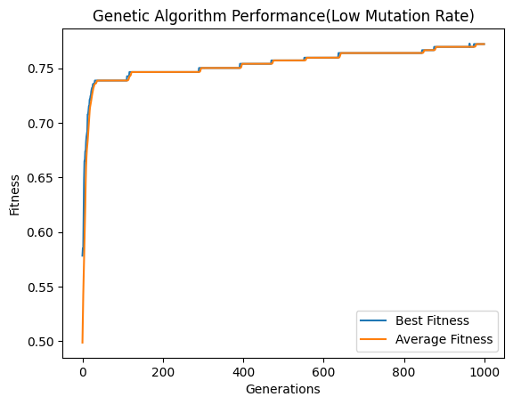

4. Low and High Population Size:
Parameters:
Low POPULATION_SIZE: 25
High POPULATION_SIZE: 300
Results:
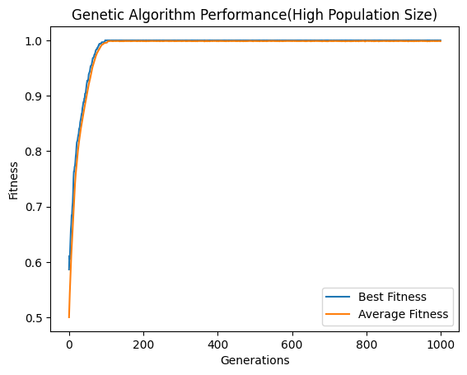
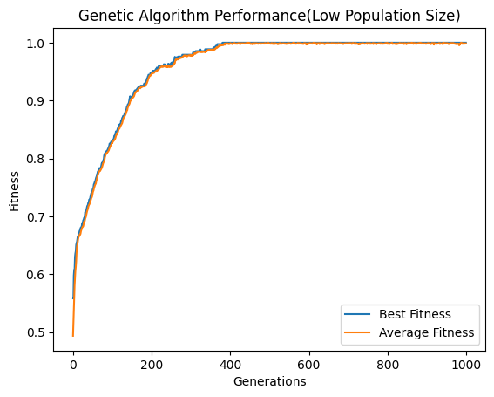

Conclusions
After completing the experiments, these conclusions are summarized in the table below.
Parameter | Low Value Effects | High Value Effects
CROSSOVER_RATE | Slower progress that depends heavily on mutation. | Faster progress but there is a risk of instability.
MUTATION_RATE | Stable but less exploration and there is a risk of stagnation. | High variability there is a risk of randomness.
POPULATION_SIZE | Faster but less diversity and prone to getting stuck in local optimum. | Slower but more diversity and better for global search.

